* **Creation Of Semester Object For Candidate Internal Result Card**
* Salesforce objects are database tables that permit you to store data that is specific to an organization.Salesforce objects are of two types:

1.Standard Objects: Standard objects are the kind of objects that are provided bysalesforce.com such as users, contracts, reports, dashboards, etc.

2.Custom Objects: Custom objects are those objects that are created by users. They supply information that is unique and essential to their organization. They are the heart of any application and provide a structure for sharing data.

* Select Setup after clicking the gear icon. Just below the home tab, select the object manager tab. Located on the far right is a Create Dropdown menu. click there, then choose Custom Object.
* Make the object as described below:

Label: Semester

Plural Label: Semesters

Record Name: Semester Name

Check the Allow Reports

Check the Allow Search

Click Save.

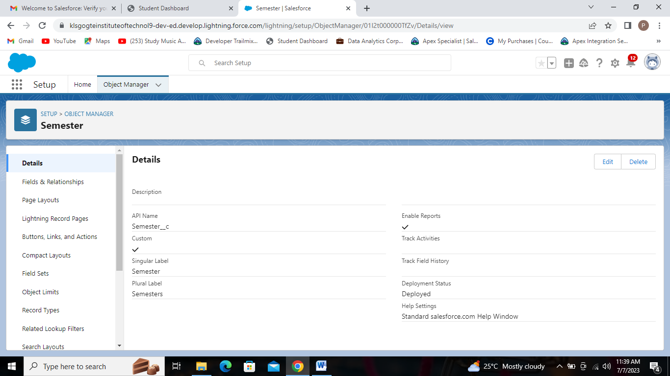

Semester Object.

* Create four additional objects in a similar manner, including Candidate, Course Details, Lecturer Details, and Internal Results.
* **Creation Of Candidate Object**
* Label: Candidate
* Plural Label: Candidates
* Record Name: Candidate Name
* Check the Allow Reports
* Check the Allow Search
* Click Save.

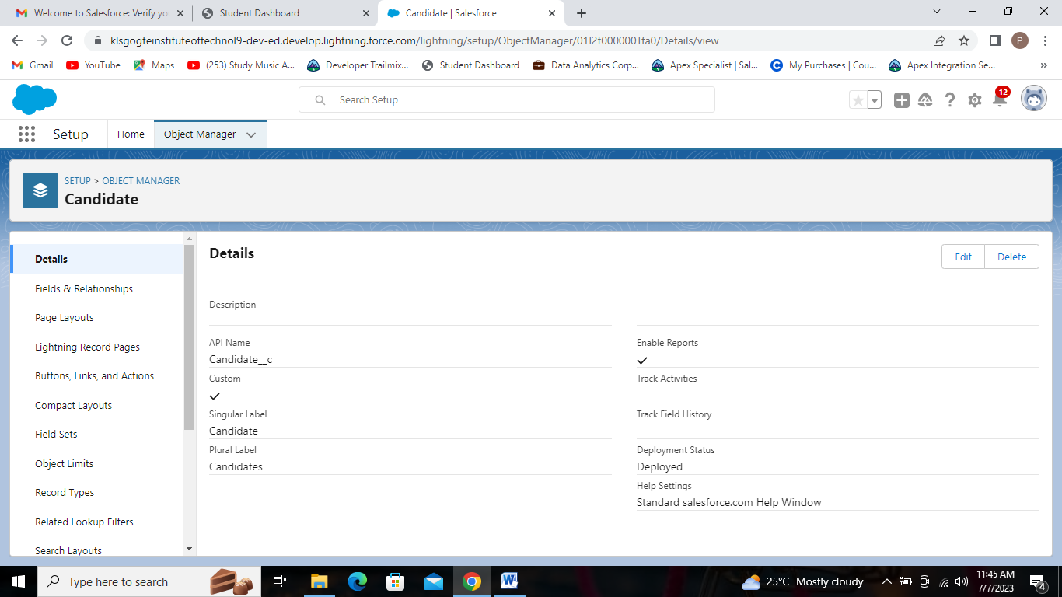

Candidate Object.

* **Creation Of Course Details Object**
* Label: Course Details
* Plural Label: Course Details
* Record Name: Course Details Name
* Check the Allow Reports
* Check the Allow Search
* Click Save.

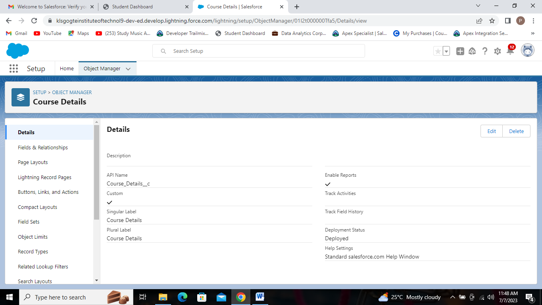

Course Details Object.

* **Creation Of Lecturer Details Object**
* Label: Lecturer Details
* Plural Label: Lecturer Details
* Record Name: Lecturer Details Name
* Check the Allow Reports
* Check the Allow Search
* Click Save.

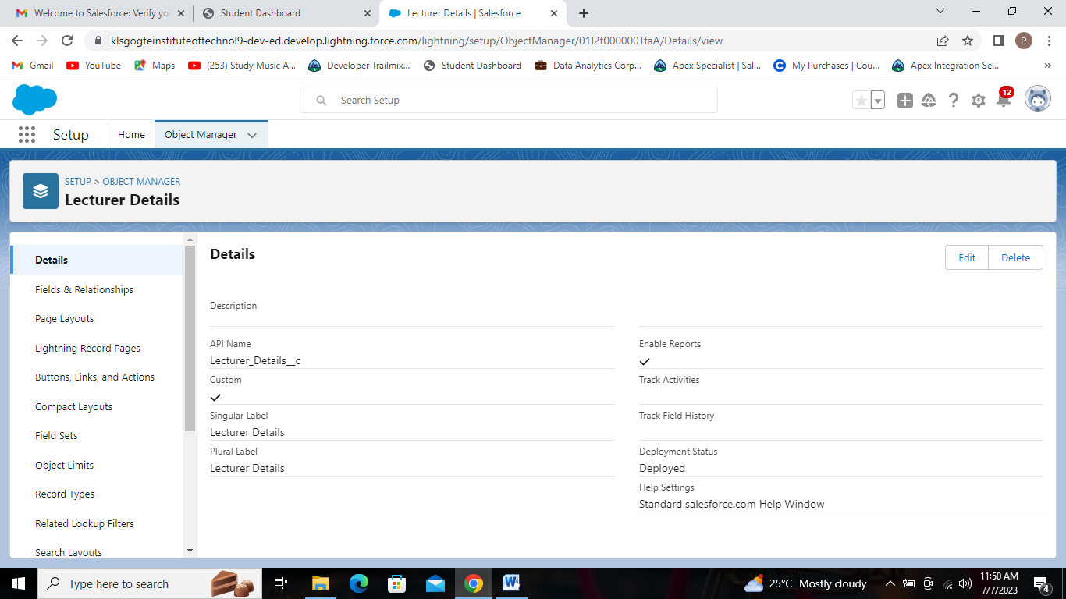

Lecturer Details Object.

* **Creation Of Internal results Object**
* Label: Internal results
* Plural Label: Internal results
* Record Name: Internal results Name
* Check the Allow Reports
* Check the Allow Search
* Click Save.

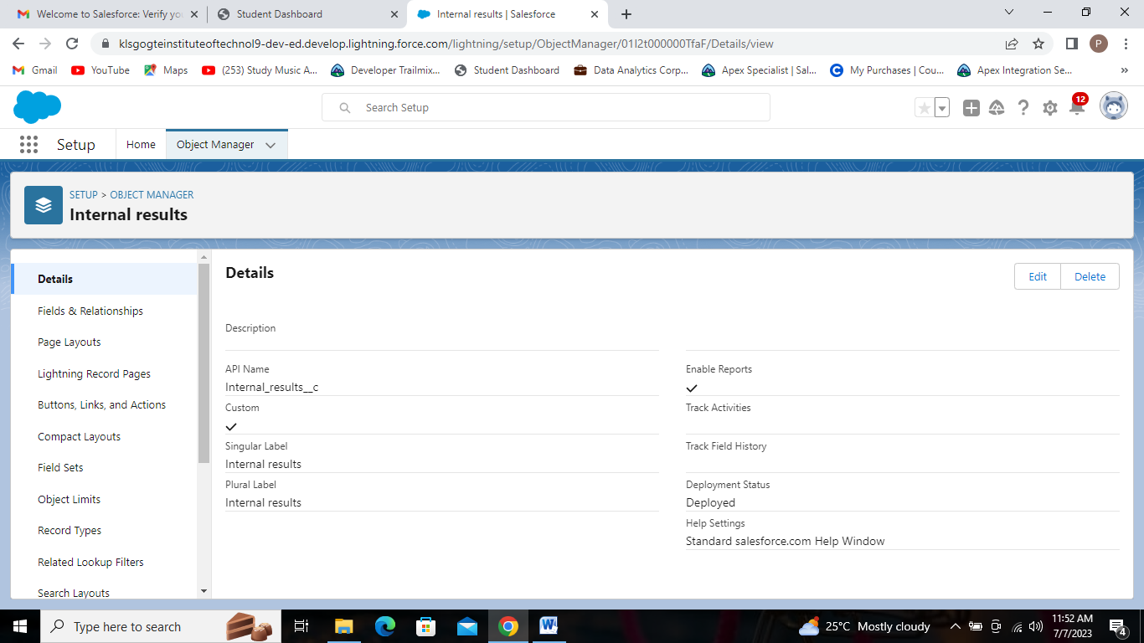

Internal results object.